Market Making and Inventory Risk
An AI-assisted experimental study of quoting decisions under inventory constraints

Introduction

Market-Making fundamentals

The Role of a Market Maker
Imagine this market, there is an imaginary asset called Asset X. Let’s assume we believe that the fair value of X is 100$. The fair value is the value we believe an asset is to be given the current information we have.
Instead of saying that the asset is worth 100$, we announce 99 | 101. This is read as 99 bid, 101 ask. This means that we are willing to BUY the asset for 99$ and willing to SELL for 101$.

Inventory and Inventory Risk
Once we buy an asset, our inventory (let’s say q) increases by 1. If we begin with nothing, q goes from 0 to +1. If q > 0, then we own assets – we are long. If q < 0, then we have sold more assets than we currently own – we are short. If q =0, we have no inventory exposure. If we are long, we benefit if the price rises. If we are short, we benefit if the price falls.
Inventory can be dangerous. Suppose we bought 10 units for 99$ each. Then the fair value falls from 100 to 90. We are now sitting on assets who have each fallen by 10$, and total approximated loss is 100$.
Market maker wants trades because traders can generate spread revenue. However, market maker does not want unlimited trades in one direction, because inventory accumulates and creates price risk.

Cash, Inventory and Mark-To-Market P&L
Key idea: cash alone does not tell you if a market is winning or losing. This is because when we buy an asset, our cash goes down, but now we own something valuable. Therefore, we must track both cash and inventory together.
Let’s return to our previous example, using a fair value of 100$ and quoting 99 | 101. Our current cash is 0$, and starting inventory (q) is 0. Therefore, our total position is worth 0.
When someone sells us one unit at 99$, our cash becomes -99$. And inventory becomes +1. Our cash may be negative, but our inventory is worth 100$, so our total wealth is +1$. We value the inventory using the current fair value.
The basic formula is PnL (profit and loss) = Cash + q * Fair Value
(Assuming we started from zero wealth)
This is called marking the inventory to market. We are asking, “if we valued everything we currently own at today’s fair value, what is our position worth?”.
Now if another customer buys that asset from us at 101$, our cash after the trade becomes -99 + 101 = +2$, and inventory becomes 0.
Therefore, our PnL is now +2 + 0 * 101 = +2$. The profit is now fully realised in cash.
After the first trade, our cash was -99$ and inventory was +1. This gave us approximately 1$ profit since the asset was worth 100$. Since we had not sold the asset, this meant the profit was unrealised. After selling the asset for 101$, our 2$ profit is realised.
When we one the asset, the fair value is 100$. Inventory risk now appears. Suppose the fair value drops to 90. Our cash hasn’t changed, and neither has our inventory. However, our PnL drops to -9. We have effectively gone from +1 to -9 without making another trade; this is inventory risk.
Long positions benefit from price rises. Suppose the fair value rises from 100 to 110, then our PnL becomes +11. As we are long one unit, every 1$ increase in the fair value increases our wealth by 1$. With 10 units, q = 10, a 1$ increase would move our wealth by 10$. This is why a large inventory matters.

The Inventory Problem

Inventory Skew
Let us now consider this question: if inventory is dangerous, what can a market maker actually do about it?
Returning to our fair value of 100 and an inventory of 0, we quote 99 | 101. We can buy or sell happily as there is not inventory problem. Now imagine customers start repeatedly selling to us. When being sold to, our inventory increases by 1 for each sale. We are now long. This means that we do not want to keep buying from others.
When we are long, we want 2 things. First is fewer people selling to us because when we buy our inventory becomes more positive. Second is more people buying from us, so our inventory falls back to 0. We can do this by changing our quote.
Suppose we now quote 98 | 100. The spread is still 100-98 = 2 as we have simply moved both prices down by 1. Our new bid is 98; this is less attractive for someone to sell to us compared to the previous bid of 99. Our new ask is 100; buying from us is now more attractive rather than buying from 101.
This is inventory skew. Our estimate of the fair value may still be 100, but since we are long, we behave as if we prefer to trade around a slightly lower centre. The shift of moving our centre of the market from 100 to 99 is inventory skew.

Now let us consider the case when we are short. Imagine q = -10, we have now sold lots of assets and want to buy more back. So, our new quote could be 100 | 102. Our bid has increased from 99 to 100, so customers are more willing to sell back to us. Our ask has increased from 101 to 102, therefore buying from us is less attractive.
If we are long, we should shift our quote down. If we are short, we should shift our quote up. If we are flat, quote around the fair value.
However, suppose the fair value is genuinely 100. If we are long and quote 98 | 100, this means we are willing to sell at 100 rather than 101, therefore we are giving up potential spread profit. We voluntarily exchange potential profit for lower inventory risk.
This trade-off is what I will be exploring in this research project.
A very aggressive inventory-control strategy may stay safer but sacrifice profitable trades. A weak inventory-control may earn more spread but occasionally accumulate huge positions.

Mathematical intuition
Let’s define the following:
- S = fair value
- q = inventory
- k = how aggressively we react to inventory

We could define our quote centre as C = S – kq

Examples
- Let S = 100, k = 0.1
- Flat
  - q = 0
  - C = 100 – 0 * 0.1 = 100
  - No inventory = No skew
- Long
  - q = 10
  - C = 100 – 10 * 0.1 = 99
  - Our quote moves down
  - If our half-spread is 1, then Bid = C – 1 = 98, and Ask = C –+1= 100
  - This gives 98 | 100
- Short
  - q = - 10
  - C = 100 – (-10) * 0.1 = 101
  - Bid = C - 1 == 100, Ask = C + 1 = 102
  - This gives 100 | 102

What does ‘k’ really mean? Suppose k = 0, then C = S regardless of inventory. The market maker completely ignores inventory. With k = 0.1, there is moderate reaction. Let’s now consider k = 1, with q = 10, C = 100 – 10 = 90. This is an enormous shift.
So larger k = more inventory-averse market maker.

Experimental Framework

Dynamic Fair Value
Real asset prices don’t sit permanently at one value. They move: 100 -> 100.5 -> 99.8 and so on. The easiest starting point to model the movement is a random walk.
A random walk means each step; the fair value moves up or down by some random amount.
For example, S(t+1) = S(t) + r(t), where r(t) is the random price change. This formula means Next fair value = Current fair value + random move.
The simplest possible random walk is letting the fair value move by either +1 or -1 with equal probability. So, if the current fair value is 100, the next fair value could be 99 or 101.
Example path: 100 -> 101 -> 100 -> 99 -> 100 -> 101
Suppose we are long, q = + 10, and the fair value moves from 100 to 99. Our wealth changes by roughly 10 x (-1) = -10. So now inventory risk becomes active rather than theoretical.

Quote-Dependent Order Flow
Instead of manually deciding BUY/SELL commands, the market maker changes its quote and that changes what customers are more likely to do.
Suppose we are long: q = + 10 . Then we deliberately shift our quote down from 99 | 101 to 97 | 99. We are trying to discourage customers from selling to us and encourage customers to buy from us.
Let’s introduce P(BUY) – the probability that the next customer buys from the market maker. If the market maker has no inventory, we want customers to be equally likely to BUY or SELL – P(BUY) = P(SELL) = 0.5 .

Suppose q > 0, our quote centre shifts down: C = S – kq. So, we want customers to become more likely to BUY from us. Therefore P(BUY) > 0.5.
If we are short, then we want customers to become more likely to SELL to us. Therefore P(BUY) < 0.5 .
Let’s introduce customer sensitivity. For now, define P(BUY) = 0.5 + a * (S-C)
Remember C = S- kq. So, if we are long, C < S, that means S – C > 0, therefore the probability of buying ( P(BUY) ) is greater than 0.5.
However, there is a problem with this formula. Extreme inventory can cause cases where P(BUY) = 1.3, which is mathematically impossible. Therefore, we must impose limits. For a simplified model, we will use 0.05 <= P(BUY) <= 0.95.

Spread-Dependent Trade Probability
We currently model which side a customer trades on using P(BUY) = 0.5 + a(S-C).
A tight quote should attract more trading than a wider quote. So we will separate customer behaviour into Trading or Not Trading, and if Trading BUYING or SELLING.
Let us define trade probability P(Trade) = 1 – b*h, where h is half spread, and b is customer sensitivity to spread width.
We will cap P(Trade) between 0.05 and 0.95.
For the simulation, values of b = 0.25, and half-spreads of 0.5, 1 and 2 produced trade probabilities of 87.5%, 75% and 50%, respectively.
This separates the probability of receiving an order from its direction and introduces a trade-off between spread revenue and trading frequency. It still remains a simplified behavioural assumption.

Python Simulation
An Excel model is useful for constructing the market-making strategy step by step and checking that each part of the model behaved correctly.
For making the model more scalable, a Python implementation is used and reproduces the same rules developed in Excel.

A single simulation is highly dependent on random outcomes. Therefore it is required for the Python model to extend to be ran repeatedly. Each run returns final PnL and maximum absolute inventory. These results are stored and averaged across many simulations. Repeated simulation gives a more useful picture of typical behaviour than one path alone. Extreme outcomes such as worst PnL are also recorded.

If one strategy sees +1, +1, -1, +1, … and the other sees -1, -1, +1, -1, …, comparing their PnL will be messy.
We want same price moves, same trade draws, same order draws, but different ‘k’. So the only thing to change is the strategy. This is a paired experiment.
Comparing strategies on independently generated path introduces unnecessary randomness. Each simulation therefore generates one market scenario first, that exact scenario is then passed to both the baseline and inventory-aware strategies. The price moves and random customer draws are identical for both. The main strategic difference is ‘k’, this created a more controlled comparison. Differences in PnL and maximum inventory can then be measured scenario by scenario.

Final Experimental Design
After constructing the model in Excel and converting it into Python, I created a final version of the simulation which could be used across all experiments. Each simulation consist of 20 market steps. The fair value followed a simple random walk and customer behaviour was determined using separate random draws for whether a trade occurred and whether the customer bought or sold.
To make a comparison fair, random market scenarios were generated independently of the market-making strategy.
The same scenarios could therefore be passed to different parameter settings. This means that when comparing 2 strategies, differences in their results were caused by the model parameters rather than one strategy simply receiving a more favourable random market path.
The final analysis used 10,000 simulated scenarios for each experimental condition. A fixed random seed was used so that the results could be reproduced. The main outcomes recorded were final PnL, maximum absolute inventory, final absolute inventory, number of executed trades and number of rejected trades.

Core equations:
- C = S – k*q
- Bid = C – h
- Ask = C + h
- P(BUY | Trade) = 0.5 + a * (S-C)
- P(Trade) = 1 – b*h
- S(t+1) = S(t) + ε(t)
- -L <= q <= L
- PnL = Cash + q * S

Baseline Market Maker

Fixed-spread Strategy
A strategy is a rule that a market maker does repeatedly. Our first strategy is simple: always quote the same spread around fair value, regardless of inventory. This is our benchmark. Having a dumb benchmark means that if later an inventory-aware strategy performs better, we need something to compare against it.
Suppose S = 100, and half spread ‘h’ = 1. Then the market maker always quotes 99 | 101.
The rules are:
- If a customer sells to us, we buy at 99
- If a customer buys from us, we sell at 101
- Inventory changes accordingly
- Cash changes accordingly
- The quote does not react to inventory (weakness of this strategy)

Weakness of the Baseline Strategy
Set the following:
- Cash = 0
- q = 0
- S = 100
- Quote 99 | 101
Suppose a customer orders SELL, SELL, BUY, SELL, SELL.
After 5 trades, Cash = -295, q = +3, PnL = 5
This strategy has made +5$ at current fair value. But it is also sitting at q = +3. Now suppose the fair value falls from 100 to 96. No trade happens.
Our new PnL is now -295 + 3(96) = -7. So, the strategy goes from +5 to -7, because it accumulated too much inventory. This is the key weakness of the baseline strategy. The strategy can keep accumulating inventory because its quoting behaviour does not change as inventory grows.

If more customer sells arrive than customer buys, the market maker tends to accumulate positive inventory. If more customer buys arrive than customer sells, the market maker tends to accumulate negative inventory. This is called order-flow imbalance.

Inventory-Aware Market Maker

Inventory-Aware Quoting Rule
Our previous baseline strategy always quoted 99 | 101 even if inventory became q = +3, + 10, +20. This is a weakness. Therefore, we can change the quote depending on the inventory.
Using the formula C = S – kq, with half spread of ‘h’, we can calculate our new bid and ask.
- Bid = C – h
- Ask = C + h
Combining these formulas, we arrive at:
- Bid = S – kq -h
- Ask = S – kq + h
This is our first complete inventory-aware strategy.

Setting parameters
Let’s suppose S = 100, h = 1, k = 0.5, q = 0, cash = 0.
Therefore C = 100, and Bid = 99, Ask = 101. Initially both strategies look identical, there is no inventory problem yet ( q = 0).
Now a customer decides to sell to us at the bid 99, so cash = -99, q = +1. Our baseline strategy still quotes 99 | 101, our inventory-aware strategy now centres C at 99.5 . Therefore, Bid = 98.5, Ask = 100.5 . So, our new quote is 98.5 | 100.5 . Our quote has moved down because we are long.
Suppose another customer still chooses to sell to us after our Bid as went down. They now sell at 98.5 . Our cash becomes -197.5, inventory is +2, and centre is 99. Therefore, we quote 98 | 100. As our inventory increases, our bid and ask decrease. The more inventory we accumulate, the more aggressively we try to get rid of it.
Currently, we are manually forcing the order flow. This means we are not modelling how customer behaviour changes when quotes change (a customer still chooses to sell to us at 98.5 in the above example when we were initially buying for 99 previously).
Now a customer buys. At q = +2, the quote is 98 | 100. A customer buys from us at the ask of 100. This shifts our quote back to 98.5 | 100.5 : the quote has moved back toward the fair value. This is because the inventory is now less extreme.
As the inventory moves away from zero, the quote skews. As inventory returns toward zero, skew reduces.

Simulation Results
Initial Strategy Comparison
The simulation in Excel attempts to answer the question of does inventory-aware quoting actually keep inventory closer to zero than a fixed-spread strategy.
The baseline strategy is the special case where the inventory sensitivity (k) is 0. For our spreadsheet, k = 0.25.
Each strategy was evaluated over 20 trades using the same realised price movements and random draws. Performance was assessed using final PnL, maximum absolute inventory, and final absolute inventory.
The inventory-aware strategy achieve a final PnL of 3.50, compared with 4.00 for the baseline. Both strategies reached a maximum absolute inventory of 4 and finished with an absolute inventory of 4. In this experiment, the baseline therefore earned 0.50 more, while inventory-aware quoting did not reduce either recorded inventory measure.
However, this one run per strategy is insufficient to establish which performs generally and repeated simulations across different random scenarios are needed

Controlled Strategy Comparison
Both strategies should experience the same fair-value shocks and underlying random customer draws.
Orders, probabilities, quotes, inventory, and PnL remain formula-drive, allowing each strategy to respond differently to identical inputs.

The inventory-aware strategy achieved a final PnL of 14.00, compared with 18.00 for the baseline. Both reached a maximum absolute inventory of 4, but final absolute inventory was 2 for the inventory-aware strategy and 4 for the baseline. At trade number 19, the same customer draw generated different orders because the strategies had different buy probabilities, showing how inventory-aware quoting can influence inventory.
In this case, inventory-aware quoting reduced the end position but did not reduce maximum inventory exposure and produced a lower PnL. These results show potential trade-off between probability and ending inventory exposure. Again, one controlled scenario cannot establish superiority.

Repeated Controlled Trials
10 controlled trials compared inventory-aware quoting k = 0.25 with the baseline strategy with k = 0, using 20 trades per strategy in each trial. Within each trial, both strategies used identical frozen order and price random draws, allowing the effect of inventory sensitivity to be compared under the same random inputs.
Metric | Inventory-Aware | Baseline
Average final PnL | 17.60 | 17.00
Average maximum absolute inventory | 3.30 | 4.30
Average final absolute inventory | 1.60 | 2.80
Worst observed final PnL | -2.00 | 0.00
Inventory-aware quoting reduced the average maximum absolute inventory by 1.00 unit and final absolute inventory by 1.20 units. These results support the hypothesis that adjusting quotes helps keep positions closer to 0 within this sample.
The average final PnL was also 0.60 higher for the inventory-aware strategy. However, it achieved the higher PnL in only 3 trials, whilst baseline achieved higher in 6, with one tie. A higher average therefore does not imply more frequent outperformance. Its worst observed final PnL was also 2.00 units below the worst for the baseline.
These results provide some evidence of improved inventory control and a small average PnL advantage. 10 short trials are still insufficient to establish statistical significance. The worst PnL in this sample does not reflect a true theoretical worst case.

Distribution of Simulation Outcomes
Averages alone do not fully describe strategy risk. 1000 paired simulations were therefore analysed as distributions. Median PnL was calculated as a measure of the typical outcome, standard deviation was used to measure variability in PnL. Proportion of negative-PnL simulations were recorded, the 5th percentile was used to examine downside outcomes without relying only on the single worst simulation. These metrics allow profitability and risk to be considered together.

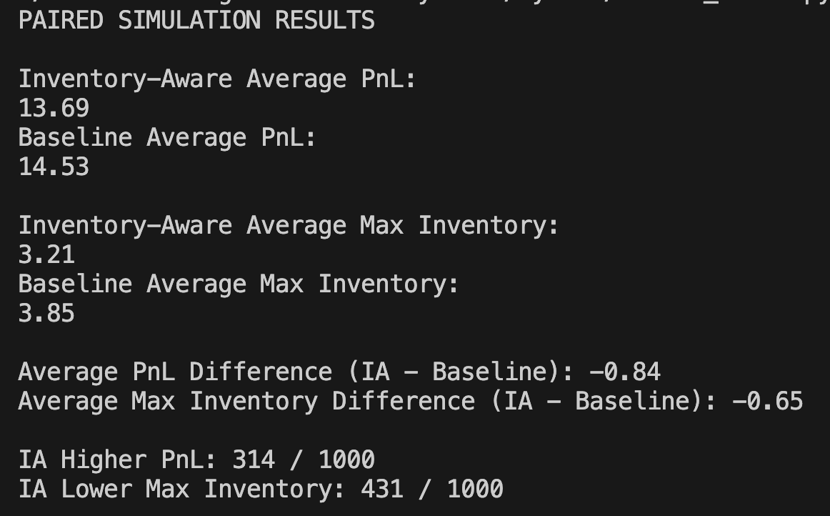
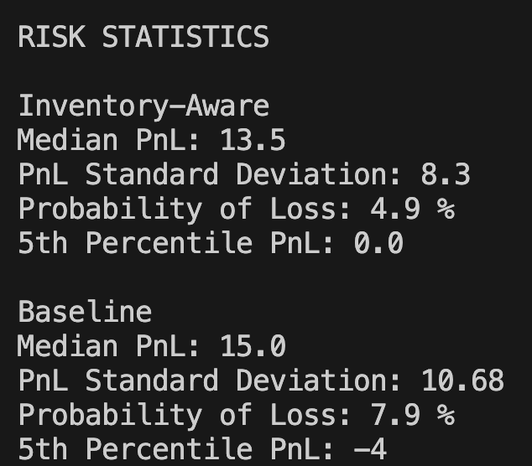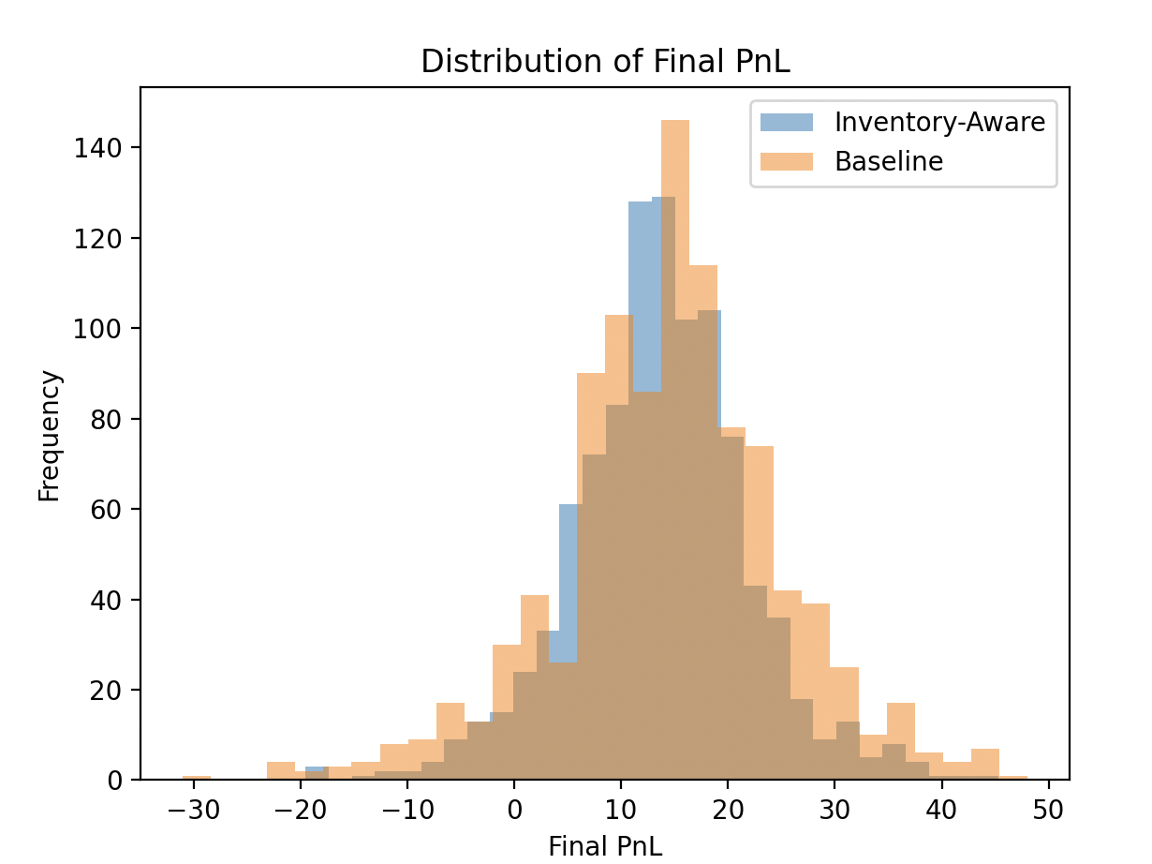

Final Monte Carlo Results
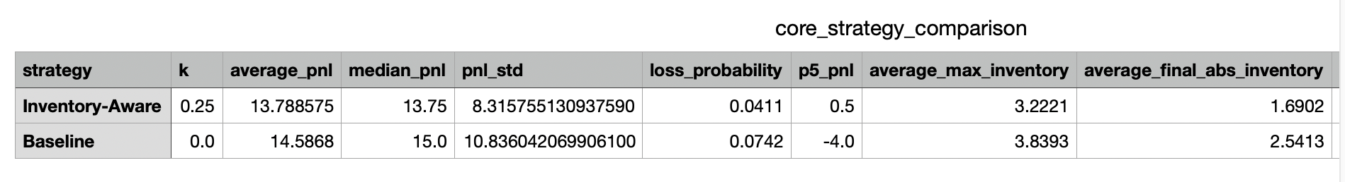
The final comparison used 10,000 paired market scenarios. The baseline strategy used k = 0, meaning that its quote centre did not respond to inventory. The inventory-aware strategy used k = 0.25. Both strategies were exposed to exactly the same underlying price directions and customer random draws in each paired simulation.
The purpose of the comparison was not simply to identify which strategy produced the highest average PnL. Inventory exposure, PnL variability, probability of loss and downside outcomes were considered alongside average profitability. This is important because a market-making strategy can produce attractive average returns while still carrying significant inventory risk.

The inventory-aware strategy produced an average PnL of 13.79, compared with 14.59 for the baseline. Its average maximum absolute inventory was 3.22 compared with 3.84. This suggests that inventory-aware strategy reduced inventory risk at the cost of a small decrease in profitability.

Sensitivity Analysis
Inventory Sensitivity
So far, we have mostly compared k = 0 against k = 0.25 . The parameter k controls how aggressively quotes react to inventory. When k is small, quote moves slightly, if k is large, quote moves aggressively. So, a trade-off is expected.
Small k
- More spread capture
- Weaker inventory control
- Larger positions

Large k
- Smaller inventory
- Safer exposure
- But quotes may move too far from fair value
- Possibly fewer profitable trades

The question to consider is how does changing k affect profit and inventory risk.
To investigate the choice of k, five values were tested: 0, 0.1, 0.25, 0.5, 1.
Each test used the same 20 trade scenario. Order and price random draws remained frozen, and all parameters were unchanged. Recordings include final PnL, maximum absolute inventory and final absolute inventory as fixed values for each value of k.

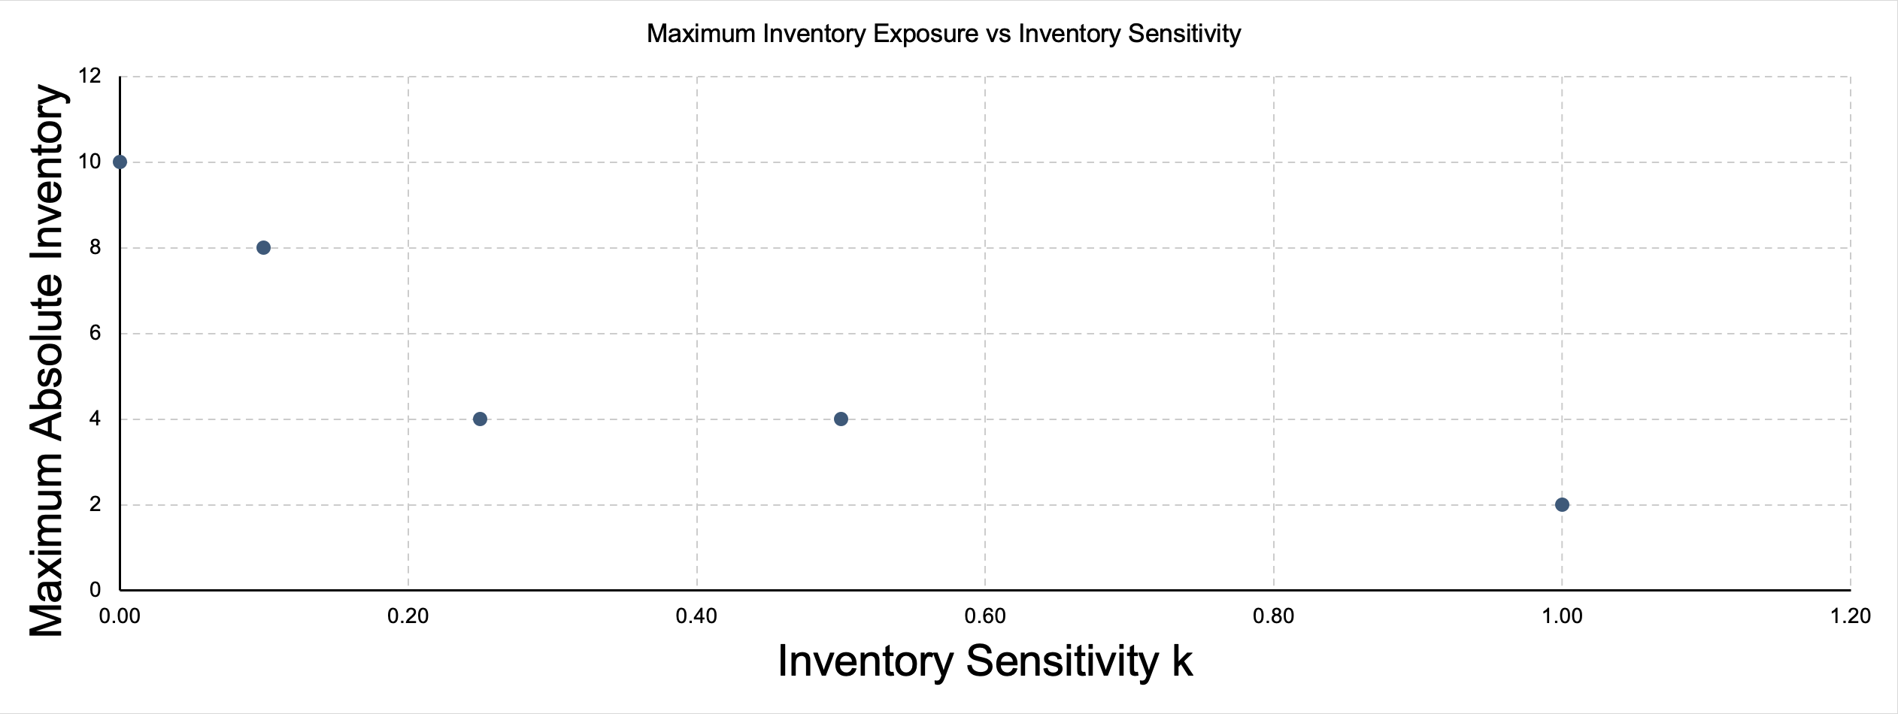
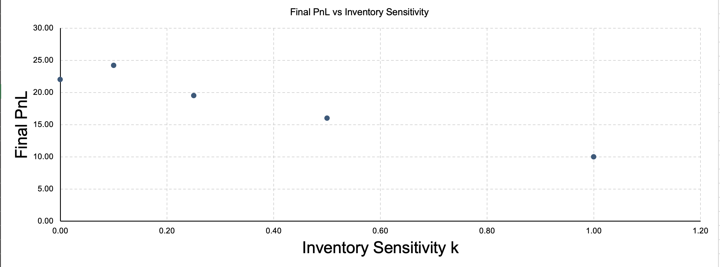

Price Volatility
Currently, how random walk involves movement of +1 and -1 only. But imagine if we could move it by +/- 2, or +/- 5. If holding inventory, bigger price moves mean bigger swings in PnL. Greater price moves means much more market risk with the same inventory.
The hypothesis is when price moves increases, larger PnL variability occurs because inventory becomes more dangerous. However, this does not necessarily mean final PnL will monotonically fall. If we are long and prices happen to rise, higher volatility could actually make us richer.
Volatility magnifies both favourable and unfavourable inventory exposure. It is not automatically a loss; it increases uncertainty and risk.

Four values were tested: 0.5, 1, 2, 3. Each run used the same frozen order draws and price directions. All four runs produced final PnL of 19.50, maximum absolute inventory of 4 and final absolute inventory of 4. In this scenario, the inventory-related prices gains and losses offset by the final trade.
From these results, we can tell that final PnL and inventory quantities alone do not fully describe market risk. Further scenarios and measures of PnL fluctuations would be needed for a broader assessment.

Inventory Limits
Our market maker currently tries to control inventory by skewing quotes. But it can still accumulate a large position if unlucky order flows keeps hitting one side.
A new safety rule to introduce is the market maker is not allowed to exceed a chosen inventory limit.
Suppose q = + 10, and we define the inventory limit as L = 10. The market maker is already at the maximum allowed long position. If another customer wants to sell to us, accepting that trade would move us to q = +11. This breaches our risk limit, so we reject the trade. Similarly, if q = -10, we should reject a customer to buy in order to prevent us to move to q = -11.
Skew is only an incentive. It makes undesirable trades less likely but does not make them impossible. A hard inventory limit acts as a final risk-control barrier.
Inventory skew = soft control
Inventory limit = hard control

In the simulation, limits of 2, 3, 5 and 10 were compared using the same frozen scenario, with k = 0.25 and price-move size fixed at 1. Each run contained 20 customer-order opportunities.
A limit of 2 resulted in 8 order rejections and a final PnL of 11.00
A limit of 3 reduced rejections to 3 and produced a PnL of 17.00
A limit of 5 and 10 both produced a PnL of 19.50 with 0 rejections

This scenario shows a trade-off between restricting inventory exposure and accepting trading opportunities. Again, further tests would be needed to assess profitability and risk more broadly.

Spread Width
A model’s conclusion is only as good as its assumptions.
So far we have changed:
- k: how strongly we react to inventory
- volatility: how much fair value moves
- L: hard inventory limit

We can also change ‘h’: half-spread.
The question to consider is does quoting wider or tighter affect profit, trading behaviour, and inventory risk.
Our bid is C – h, and our ask is C + h.
So the full spread is 2h. If h = 1, then around C = 100 the quote is 99 | 101. If h =2, then quote becomes 98 | 102. Our spread has increased from 2 to 4.
A wider spread can mean more profit per successful round trip. Imagine buying at 98 and selling at 102. However, quoting a massive spread such as 50 | 150 on an asset worth around 100 would be less attractive for someone to trade with us.
The current model uses P(BUY) = 0.5 + a(S-C)
Our customers react to the quote centre, but not directly to how wide the spread is. That means if we simply increase h from 1 to 5, our current model may still generate roughly the same number of customer orders. This is unrealistic and a limitation of the model.

To address this, we test values of h of 0.5, 1, 1.5, 2. Other factors are fixed. The same frozen order and price random draws were used for all four 20 runs.
The final PnL increased from 9.50 to 19.50, 29.50, and 39.50 respectively. Maximum absolute inventory remained 4, with 0 rejected trades in every run. Each increase of 0.5 in the half-spread therefore increased final PnL by exactly 10.
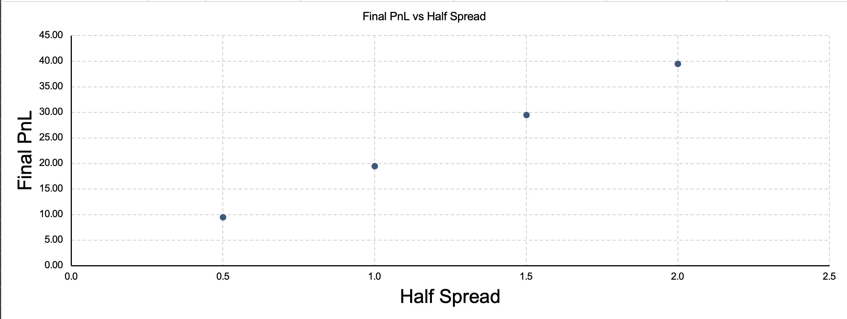
It is important to note that these results do not show that wider spreads are always better. They reveal that the model lacks the reduction in customer willingness to trade that less competitive quotes would be expected to cause.

Repeated Inventory Sensitivity Analysis
The earlier inventory sensitivity experiment examined different values of k under a limited number of market paths. Python allows this to be extended across 1000 simulated scenarios. Values of k = 0, 0.1, 0.25, 0.5 and 1.0 were tested.
For each value of k, average PnL, PnL standard deviation, average maximum absolute inventory, probability of loss and the 5th percentile PnL were calculated.
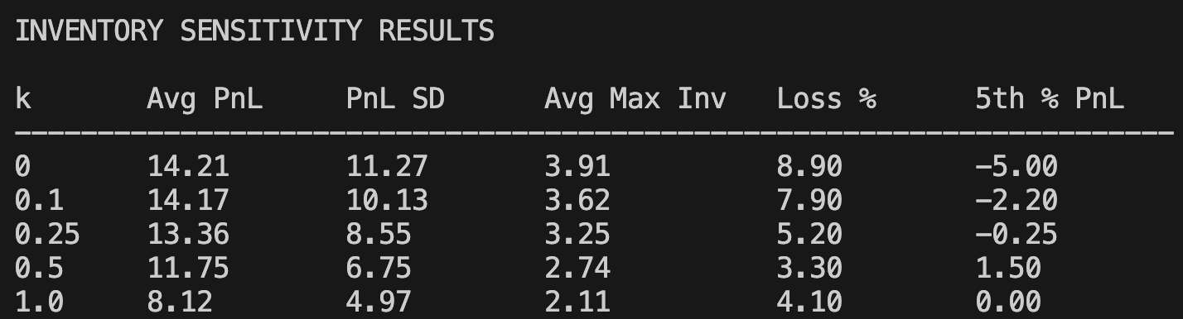
This allows the effect of stronger inventory control to be examined in terms of both profitability and risk rather than relying on a single simulation.
What each column tells us
- Avg PnL
  - Typical profitability
- PnL SD
  - How variable the outcomes are
- Avg Max Inv
  - How far inventory tends to drift from 0
- Loss %
  - Fractions of simulations where PnL < 0
- 5th % PnL
  - A measure of bad downside outcomes without obsessing over one anomalous worst simulation

Repeated Volatility Sensitivity Analysis
As volatility rises, PnL standard deviation tends to rise and worse downside outcomes. But the average max inventory may barely change. This is because our current quoting strategy reacts to but doesn’t react directly to volatility. So the same amount of inventory becomes more dangerous without the market maker necessarily reducing it.
The earlier volatility experiment was extended using 1000 simulated market scenarios. Inventory sensitivity was held fixed as k = 0.25, while the magnitude of each fair-value movement was varied between 0.5, 1, 2, and 3. The direction of each price movement and the random customer draws were held constant across volatility levels, allowing the effect of price-movement magnitude to be isolated.
For each level, average PnL, PnL standard deviation, average maximum absolute inventory, probability of loss and 5th percentile PnL were recorded. This allows the effect of increased market volatility on both profitability and downside risk to be examined.

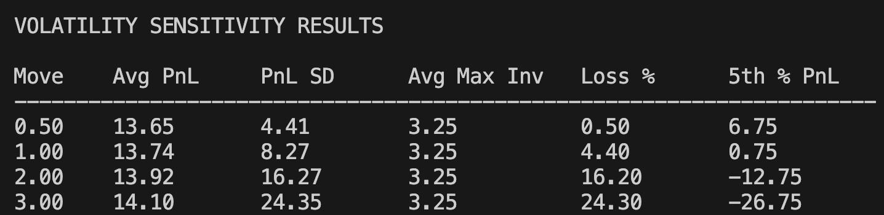

Repeated Inventory Limit Sensitivity Analysis
The question to consider is how does tightening the hard inventory limit affect risk, rejected trades and PnL across many market scenarios.
The effect of hard inventory limits was examined across 1000 simulated market scenarios. Inventory sensitivity fixed at k = 0.25, while inventory limits of 2, 3, 5 and 10 were tested.
Each limit was evaluated using the same underlying market scenarios. Average PnL, PnL standard deviation, average maximum absolute inventory, probability of loss, 5th percentile PnL and the average number of rejected trades were recorded. This allows the reduction in inventory exposure from tighter limits to be compared against the potential cost of rejecting trading opportunities.

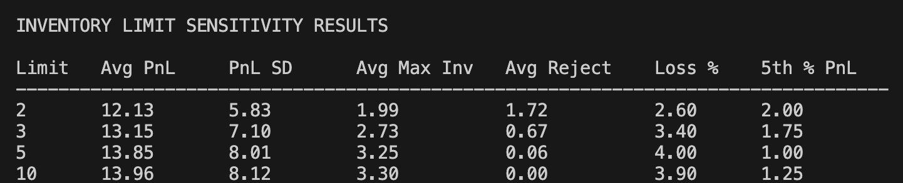

Repeated Spread Sensitivity Analysis
We test h = 0.5, 1, 1.5, 2 while keeping k = 0.25 and using the same 1000 market scenarios for every spread. A larger h gives more potential revenue per executed trade. But our model also says P(Trade) = 1 – b*h, so increasing h should reduce trading frequency.
This creates a trade-off where a wider spread leads to more revenue per trade, but fewer trades.
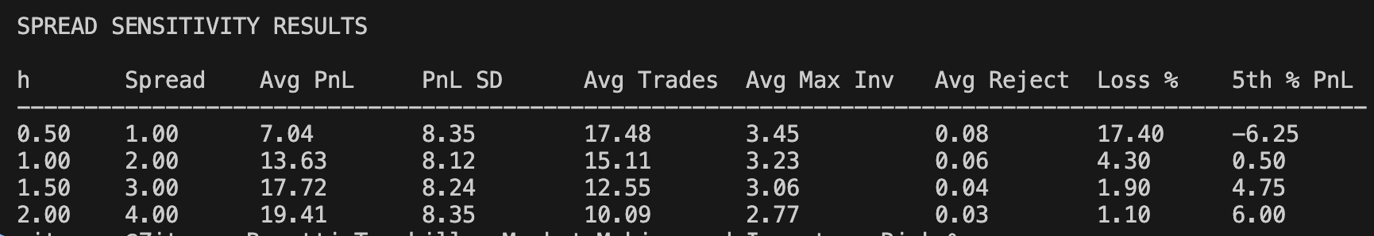

Repeated Inventory Sensitivity Analysis
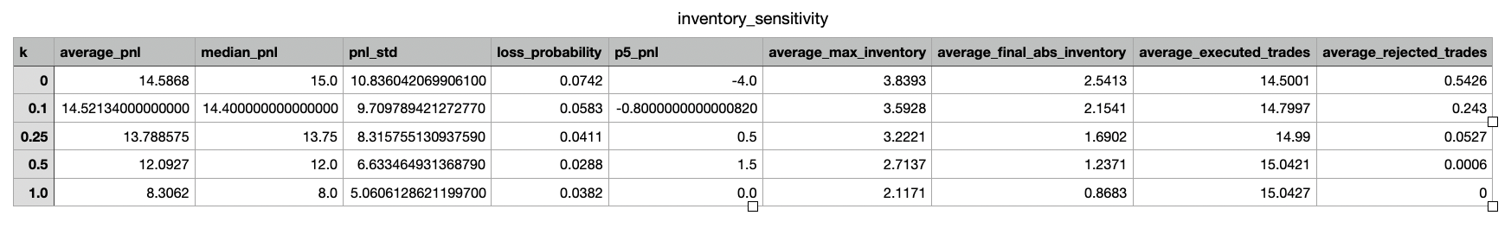
Increasing k caused the market maker to respond more strongly to inventory. The results show that as ‘k’ increased, the average maximum inventory decreased. At the same time, the average PnL also decreased. This indicates that inventory sensitivity cannot be evaluate using profitability alone.
A larger k changes both the market maker’s inventory exposure and the prices at which it is willing to trade. The results therefore reveal a trade-off between inventory control and trading profitability rather than a simple rule that larger k is always preferable.

Repeated Volatility Sensitivity Analysis
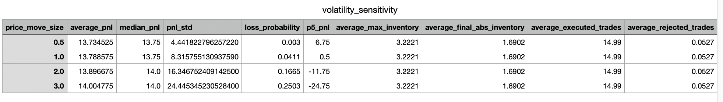
Increasing the price-movement size increased the financial significance of holding inventory. The most important result was the change in PnL dispersion. PnL standard deviation changed from 4.442 when price movements were 0.5 to 24.45 when price movements were 3.
Maximum inventory exposure did not change as volatility increased. This is important because the quoting rule C = S – k*q responds directly to inventory but not to volatility. Therefore, the same inventory position can become considerably riskier in a move volatile market without the strategy necessarily reacting more strongly.

Repeated Inventory Limit Sensitivity Analysis
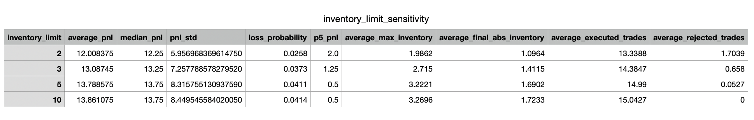
Hard inventory limits provided a different form of risk control from inventory skew. Inventory skew attempts to influence future customer behaviour, whereas the hard limit prevents a trade from executing once the permission position is reached.
Tightening the inventory limit from 2 to 10 changed average maximum inventory from 1.9862 to 3.2696, while the average number of rejected trades changed from 1.7039 to 0.
This demonstrates the cost of hard risk constraints. Tighter limits can restrict inventory exposure, but they may also prevent trades which could otherwise have generated spread revenue.

Repeated Spread Sensitivity Analysis
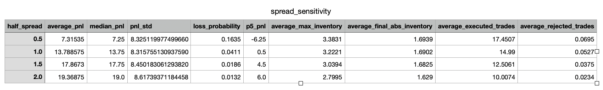
Spread width affects two opposing parts of the model. Increasing the half-spread increase the potential revenue earned from an executed trade, but the spread-dependent customer model simultaneously reduces the probability that a customer trades.
As the half-spread increased from 0.5 to 2, the average number of executed trades changed from 17.5 to 10.0. Average PnL changed from 7.31 to 19.4. The results therefore show that spread selection involves a balance between revenue per trade and trading frequency.

Discussion
The central idea investigated in this project was that market making involves a conflict between earning the bid-ask spread and controlling inventory risk. A market maker benefits from receiving trades, but repeated trades in the same direction can create a large, long or short position. Once inventory has accumulated, movements in fair value can have a substantial effect on total PnL.
The baseline model demonstrated this problem because its quotes remained centred around fair value regardless of inventory. The inventory-aware strategy introduced a simple linear skew, C = S – k*q. Positive inventory moved the quote centre downward, encouraging customers to buy from the market maker, while negative inventory moved the quote upward and encouraged customers to sell.
The simulation results show that strategy performance cannot be described using PnL alone. Maximum inventory, PnL, variability, downside out comes and trade frequency all provide additional information about the risk being taken. This became particularly clear in the sensitivity experiments, where changing inventory sensitivity, volatility, inventory limits and spread width affected different parts of the strategy.
The project also helped me highlight the importance of experimental design. Early comparisons used individual random simulations, which could give misleading conclusions because 2 strategies might experience different market paths. Generating market scenarios separately and applying the same scenarios to each strategy created a more controlled comparison.
Repeating this process across 10,000 simulations reduced the dependence of the conclusions on a small number of random outcomes.
Overall, the experiments demonstrated that inventory control should be viewed as a risk-management problem rather than simply a method for maximising immediate PnL. More aggressive inventory management can change both the distribution of returns and the amount of inventory held, while hard limits and spread changes introduce additional trade-offs.

Role of AI
Role of Artificial Intelligence
AI was used as a tool throughout the project rather than as a replacement for the research process. At the beginning of the project, AI was primarily used as a tutor to explain market-making concepts including bid and ask prices.
As the project developed, I used AI to help translate these ideas into an Excel model and later into Python. This included assistance with spreadsheet formulates, debugging, code structure and experimental design.
AI was also used to question limitations in the model. The final experimental decisions and interpretation of results were based on the behaviour of the model rather than simply accepting generated conclusions. AI mainly accelerated explanation, implementation and debugging while the project remained an iterative process of modelling, testing and revision.

Limitations
The model developed in this project was intentionally simplified and not to be interpretated as a realistic trading system.
Fair value follows a discrete symmetric random walk. Real asset prices have more complicated behaviour, including changing volatility, jumps, trends and dependence between observations.
Customer behaviour is represented using simplified probability rules. The probability of buying depends linearly on the difference between fair value and quote centre, while trading probability depends linearly on the half-spread. Real order flow depends on many additional factors including competing market makers, availability liquidity, order-book depth, information and recent price movements.
Every executed order has a size of one unit. Real markets contain variable order sizes, which can cause inventory to change much more abruptly.
The model does not contain informed traders or adverse selection. A real market maker may trade with participants who possess information about future price movements. In those situations, receiving a trade can itself provide information about fair value.
The model ignores latency, queue position, exchange fees, transaction costs and competition from other liquidity providers.
Finally, the inventory-skew rule C = S – k*q is deliberately simple. It reacts to inventory but does not directly account for volatility, remaining trading horizon or other measures of risk. More advanced market-making models could incorporate these variables when determining reservation prices and optimal spreads.
These limitations mean that the numerical results should be interperated as properties of the experimental model rather than predictions of real-world market-making profitability. The purpose of the simulation is to isolate and investigate the relationship between quoting decisions and inventory risk.

Conclusion
To sum it up one more time, this project investigated how inventory affects the behaviour and risk of a simplified market maker. Beginning with a fixed-spread benchmark, the model was progressively extended to include dynamic fair value, inventory-aware quoting, quote-depending customer behaviour, spread-dependent trade probability and hard inventory limits.
The main mechanism investigated was inventory-adjusted quote centre C = S – k*q.
This allows a market maker with positive inventory to shift its quotes downward and encourage customers to buy, while a market maker with negative inventory shifts quotes upward to encourage customers to sell. Repeated Monte Carlo simulation allowed the baseline and inventory-aware strategies to be evaluated across common market scenarios.
The central conclusion is that market making involves balancing spread capture, trading frequency and exposure to inventory risk. The appropriate quoting behaviour depends on both the market environment and the level of risk the market maker is willing to carry.

